Ex1:

import java.util.Scanner;

public class Main {

public static void main(String[] args)

{

Scanner input = new Scanner (System.in);

System.out.print("Input your first name: ");

String fname = input.next();

System.out.print("Input your last name: ");

String lname = input.next();

System.out.println();

System.out.println("Hello \n"+fname+" "+lname);

}

}

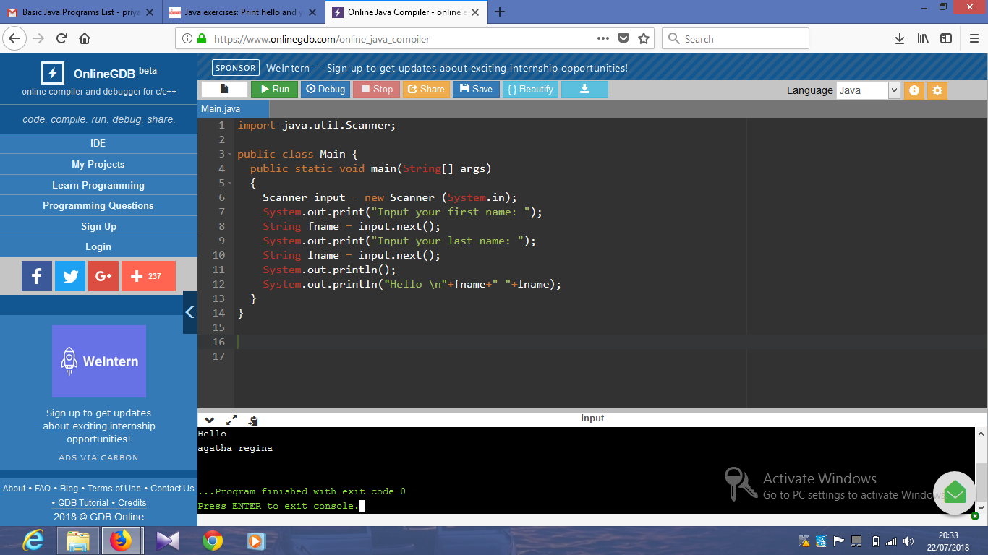

Ex2:

import java.util.Scanner;

public class Main {

public static void main(String[] args)

{

Scanner input = new Scanner (System.in);

System.out.print("Input the first number: ");

int num1 = input.nextInt();

System.out.print("Input the second number: ");

int num2 = input.nextInt();

int sum = num1 + num2;

System.out.println();

System.out.println("Sum: "+sum);

}

}

Output:

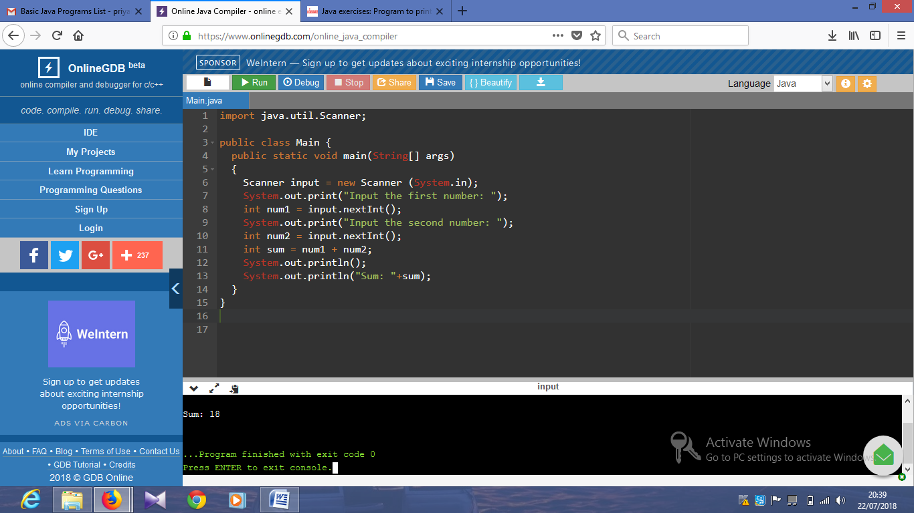

import java.util.Scanner;

public class Main {

public static void main(String[] args)

{

Scanner input = new Scanner (System.in);

System.out.print("Input the first number: ");

int a = input.nextInt();

System.out.print("Input the second number: ");

int b = input.nextInt();

int d = (a/b);

System.out.println();

System.out.println("The division of a and b is:" +d);

}

}

Output:

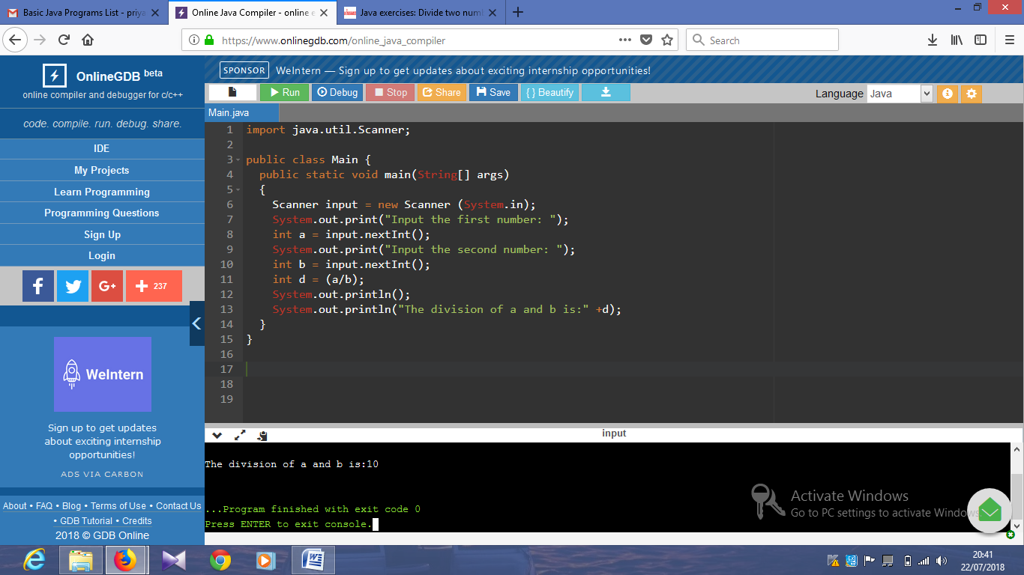

public class Main {

public static void main(String[] args) {

int w = -5 + 8 * 6;

int x = (55 + 9) % 9;

int y = 20 + (-3 * 5 / 8);

int z = 5 + 15 / 3 * 2 - 8 % 3;

System.out.print(w + "\n" + x + "\n" + y + "\n" + z);

}

}

Output:

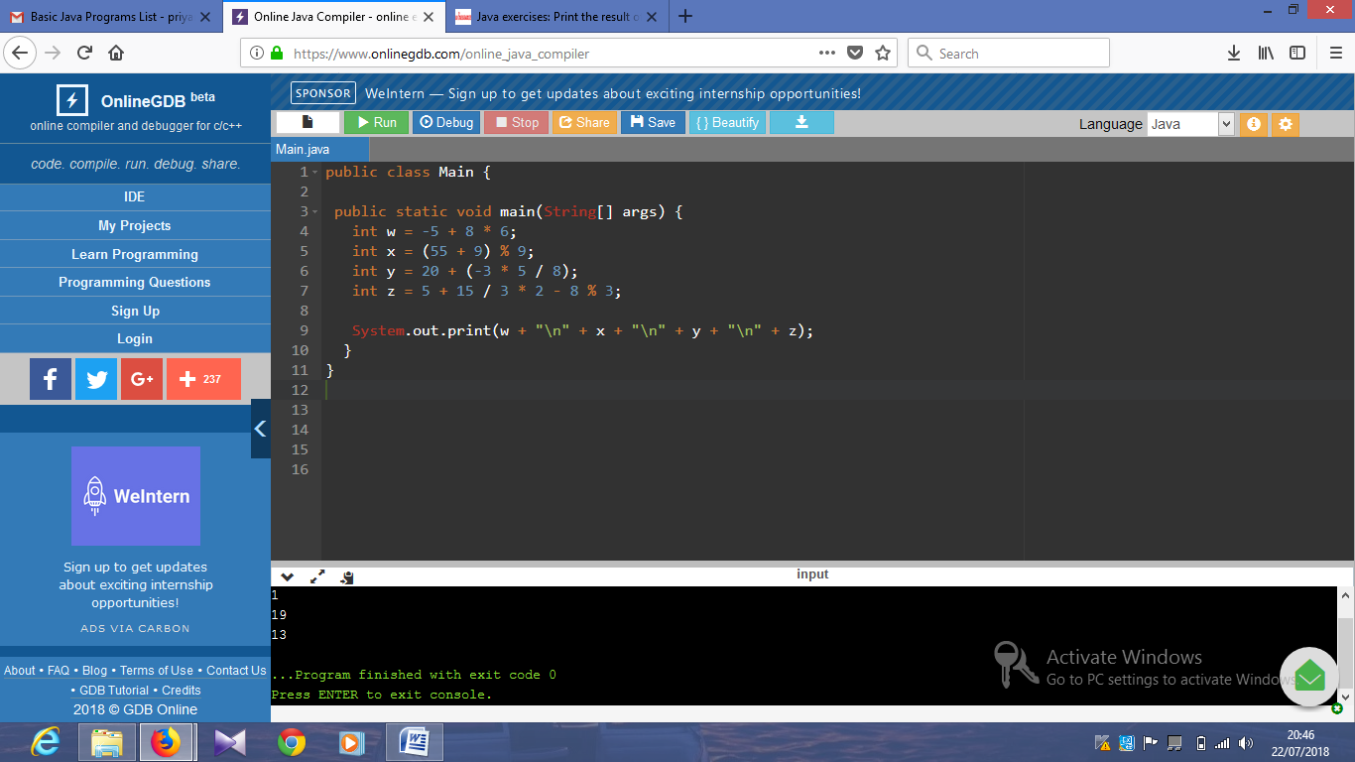

public class Main

{

static int x = 25;

static int y = 5;

public static void main(String[] args)

{

System.out.println(x*y);

}

}

Output:

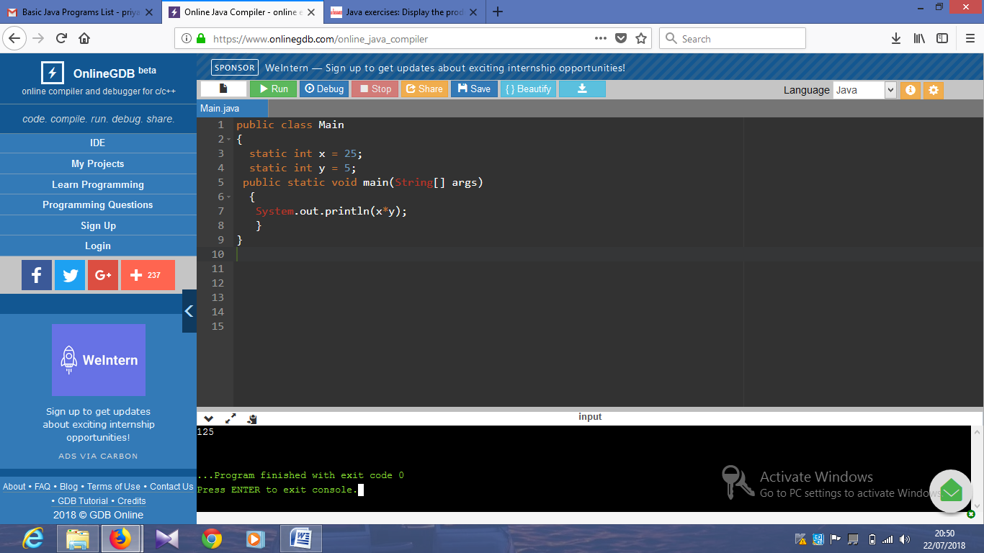

import java.util.Scanner;

public class Exercise6 {

public static void main(String[] args) {

Scanner in = new Scanner(System.in);

System.out.print("Input first number: ");

int num1 = in.nextInt();

System.out.print("Input second number: ");

int num2 = in.nextInt();

System.out.println(num1 + " + " + num2 + " = " +

(num1 + num2));

System.out.println(num1 + " - " + num2 + " = " +

(num1 - num2));

System.out.println(num1 + " x " + num2 + " = " +

(num1 * num2));

System.out.println(num1 + " / " + num2 + " = " +

(num1 / num2));

System.out.println(num1 + " mod " + num2 + " = " +

(num1 % num2));

}

}

import java.util.Scanner;

public class Main {

public static void main(String[] args) {

Scanner in = new Scanner(System.in);

System.out.println("Input the Number: ");

int n = in .nextInt();

for (int i = 1; i <= 10; i++) {

System.out.println(n + "*" + i + " = " + (n * i));

}

}

}

Output:

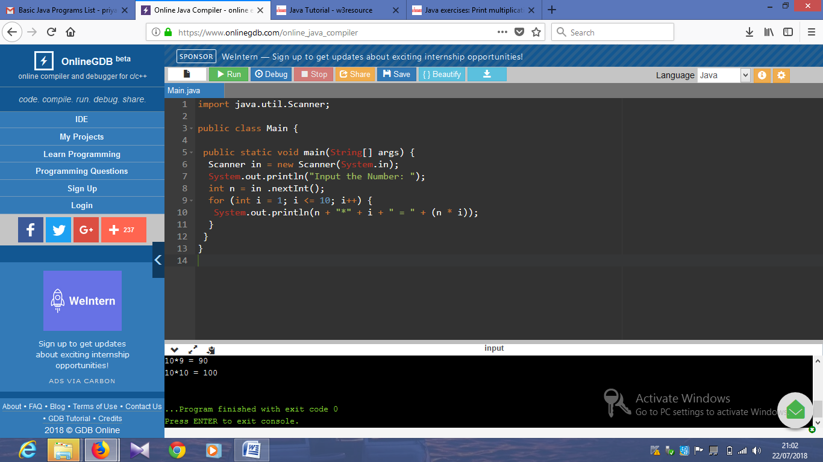

public class Exercise8 {

public static void main(String[] args) {

System.out.println(" J a v v a ");

System.out.println(" J a a v v a a");

System.out.println("J J aaaaa V V aaaaa");

System.out.println(" JJ a a V a a");

}

}

Output:

public class Exercise10 {

public static void main(String[] args) {

double pi = 4.0 * (1 - (1.0/3) + (1.0/5) - (1.0/7) + (1.0/9) - (1.0/11));

System.out.println(pi); //

}

}

Output:

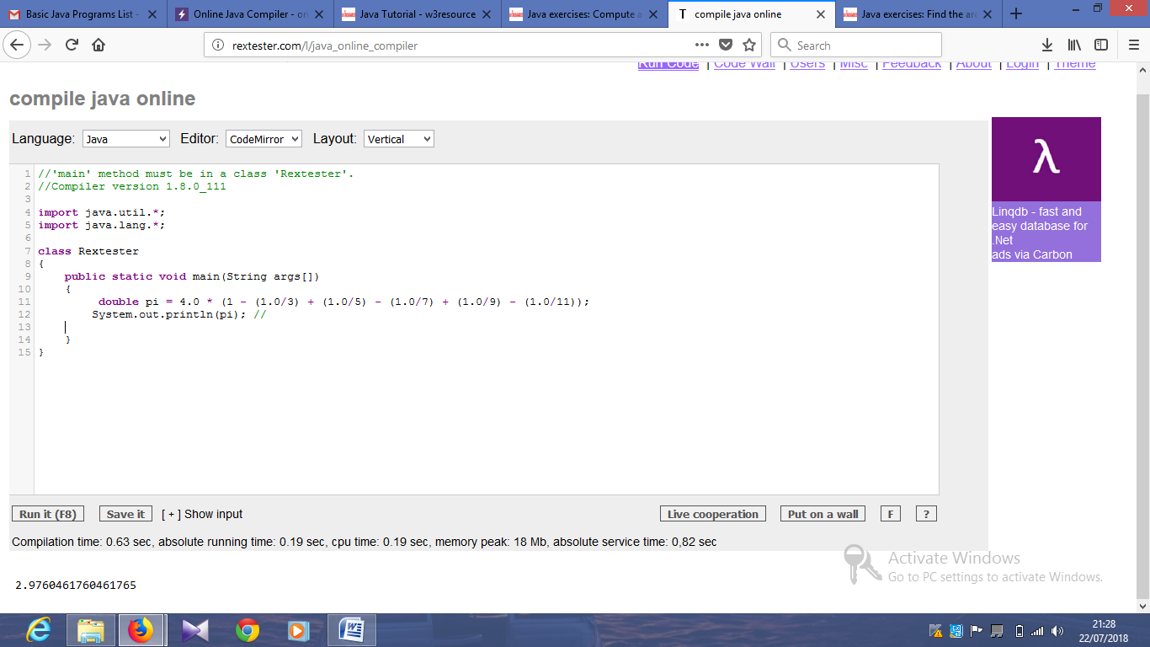

import java.util.Scanner;

public class Main {

public static void main(String[] args) {

Scanner io = new Scanner(System.in);

System.out.println("Input the radius of the circle: ");

double radius = io.nextDouble();

System.out.println("Perimeter is = " + (2 * radius * Math.PI));

System.out.println("Area is = " + (Math.PI * radius * radius));

}

}

Output:

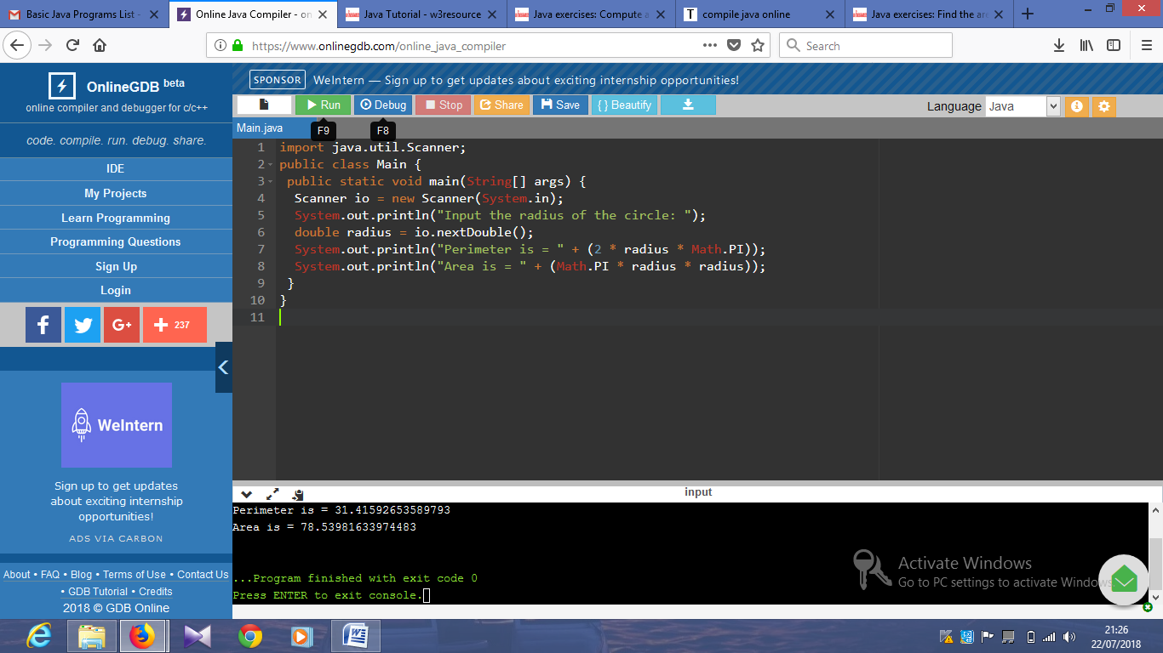

import java.util.Scanner;

public class Main {

public static void main(String[] args) {

double num = 0;

double x = 1;

Scanner sc = new Scanner(System.in);

System.out.println("Input the number(n) you want to calculate the average: ");

int n = sc.nextInt();

while (x <= n) {

System.out.println("Input number " + "("+ (int) x +")" + ":");

num += sc.nextInt();

x += 1;

}

double avgn = (num / n);

System.out.println("Average:" + avgn);

}

}

Output:

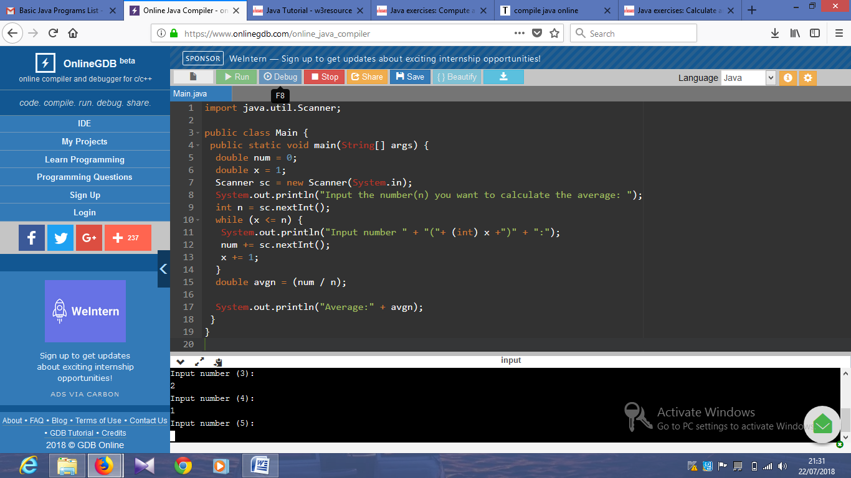

System.out.println("* * * * * * ==================================");

System.out.println(" * * * * * ==================================");

System.out.println("* * * * * * ==================================");

System.out.println(" * * * * * ==================================");

System.out.println("* * * * * * ==================================");

System.out.println(" * * * * * ==================================");

System.out.println("* * * * * * ==================================");

System.out.println(" * * * * * ==================================");

System.out.println("* * * * * * ==================================");

System.out.println("==============================================");

System.out.println("==============================================");

System.out.println("==============================================");

System.out.println("==============================================");

System.out.println("==============================================");

System.out.println("==============================================");

}

}

Output:

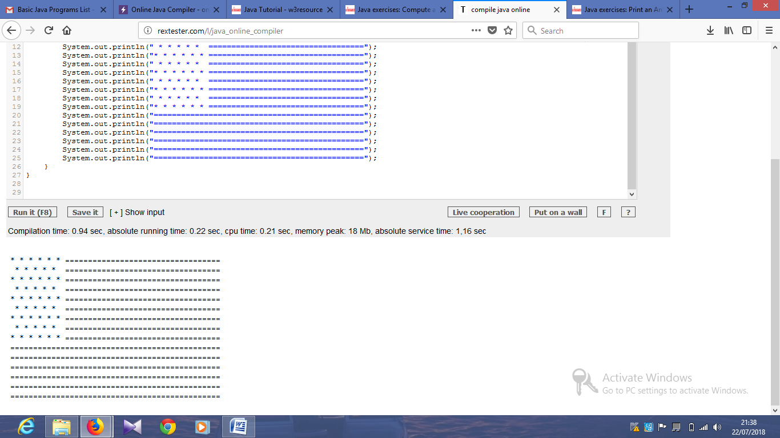

import java.util.Scanner;

public class Main {

public static void main(String[] args) {

int x, y, z;

Scanner in = new Scanner(System.in);

System.out.println("Input the first number: ");

x = in.nextInt();

System.out.println("Input the second number: ");

y = in.nextInt();

z = x;

x = y;

y = z;

System.out.println(" Swapped values are3:" + x + " and " + y);

}

}

Output:

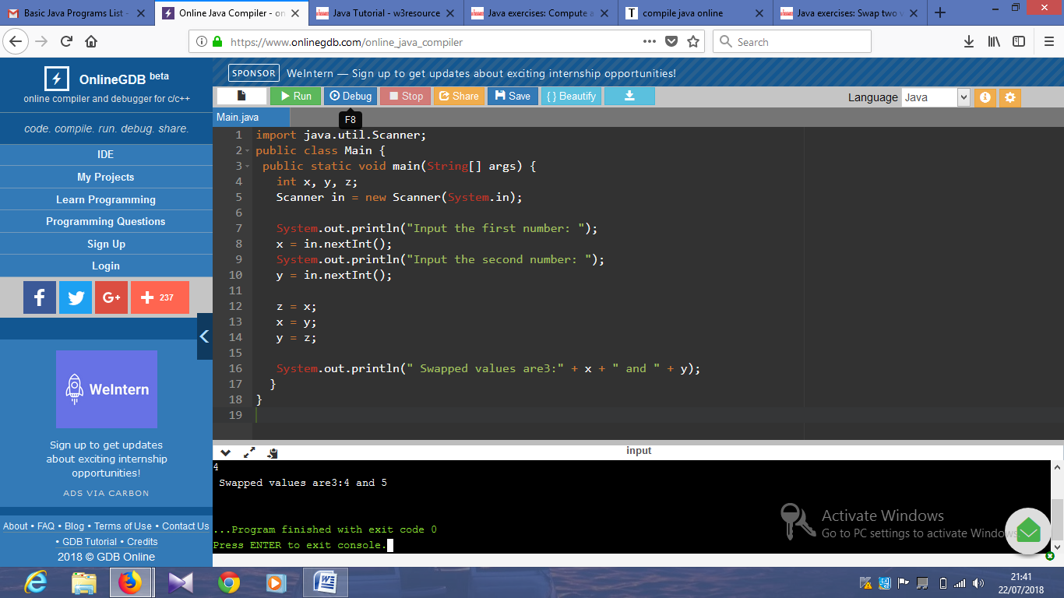

public class Exercise16 {

public static void main(String[] args)

{

System.out.println(" +\"\"\"\"\"+ ");

System.out.println("[| o o |]");

System.out.println(" | ^ | ");

System.out.println(" | '-' | ");

System.out.println(" +-----+ ");

}

}

Output:

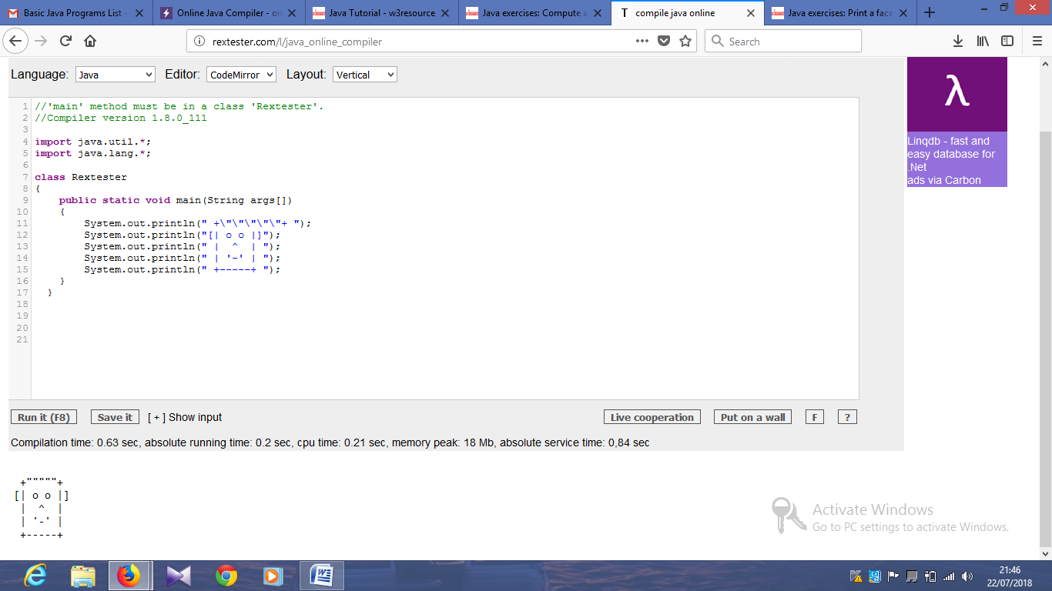

long binary1, binary2;

int i = 0, remainder = 0;

int[] sum = new int[20];

Scanner in = new Scanner(System.in);

System.out.print("Input first binary number: ");

binary1 = in.nextLong();

System.out.print("Input second binary number: ");

binary2 = in.nextLong();

while (binary1 != 0 || binary2 != 0)

{

sum[i++] = (int)((binary1 % 10 + binary2 % 10 + remainder) % 2);

remainder = (int)((binary1 % 10 + binary2 % 10 + remainder) / 2);

binary1 = binary1 / 10;

binary2 = binary2 / 10;

}

if (remainder != 0) {

sum[i++] = remainder;

}

--i;

System.out.print("Sum of two binary numbers: ");

while (i >= 0) {

System.out.print(sum[i--]);

}

System.out.print("\n");

}

}

long binary1, binary2, multiply = 0;

int digit, factor = 1;

Scanner in = new Scanner(System.in);

System.out.print("Input the first binary number: ");

binary1 = in.nextLong();

System.out.print("Input the second binary number: ");

binary2 = in.nextLong();

while (binary2 != 0)

{

digit = (int)(binary2 % 10);

if (digit == 1)

{

binary1 = binary1 * factor;

multiply = binaryproduct((int) binary1, (int) multiply);

}

else

{

binary1 = binary1 * factor;

}

binary2 = binary2 / 10;

factor = 10;

}

System.out.print("Product of two binary numbers: " + multiply+"\n");

}

static int binaryproduct(int binary1, int binary2)

{

int i = 0, remainder = 0;

int[] sum = new int[20];

int binary_prod_result = 0;

while (binary1 != 0 || binary2 != 0)

{

sum[i++] = (binary1 % 10 + binary2 % 10 + remainder) % 2;

remainder = (binary1 % 10 + binary2 % 10 + remainder) / 2;

binary1 = binary1 / 10;

binary2 = binary2 / 10;

}

if (remainder != 0)

{

sum[i++] = remainder;

}

--i;

while (i >= 0)

{

binary_prod_result = binary_prod_result * 10 + sum[i--];

}

return binary_prod_result;

}

}

|  |
| --- |
| class DectoBin  {  public static void main(String arg[])  {      Scanner sc=new Scanner(System.in);      System.out.println("Enter a decimal number");      int n=sc.nextInt();      int  bin[]=new int[100];      int i = 0;      while(n > 0)      {      bin[i++] = n%2;         n = n/2;      }     System.out.print("Binary number is : ");      for(int j = i-1;j >= 0;j--)     {         System.out.print(bin[j]);     }  }  } |

|  |  |
| --- | --- |
| Output: |  |

import java.util.Scanner;

public class Exercise21 {

public static void main(String args[])

{

int dec_num, rem, quot, i=1, j;

int oct_num[] = new int[100];

Scanner scan = new Scanner(System.in);

System.out.print("Input a Decimal Number: ");

dec_num = scan.nextInt();

quot = dec_num;

while(quot != 0)

{

oct_num[i++] = quot%8;

quot = quot/8;

}

System.out.print("Octal number is: ");

for(j=i-1; j>0; j--)

{

System.out.print(oct_num[j]);

}

System.out.print("\n");

}

}

}

Output:

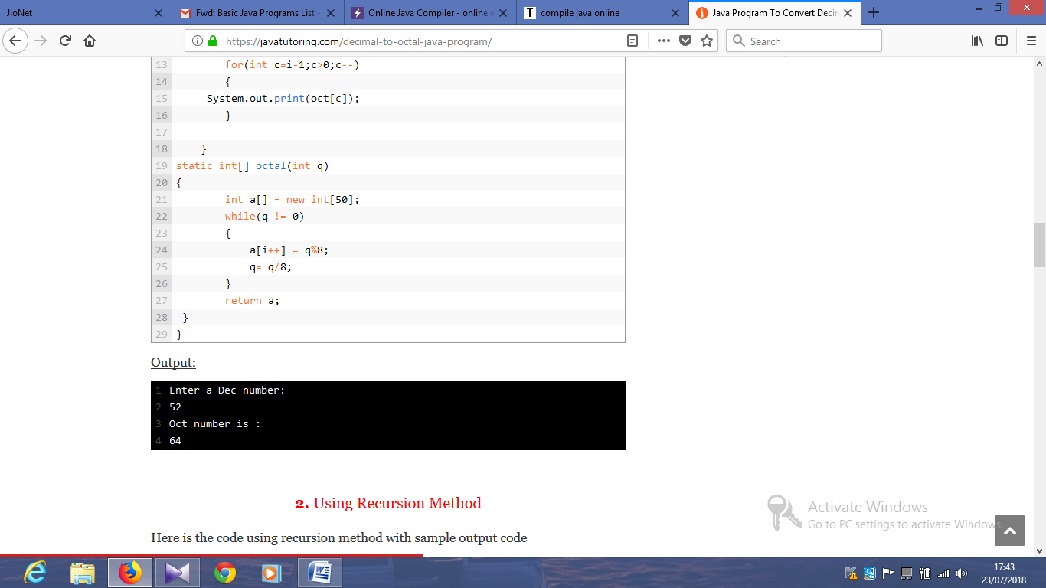

import java.util.Scanner;

public class Exercise20 {

public static void main(String args[])

{

int dec_num, rem;

String hexdec_num="";

/* hexadecimal number digits */

char hex[]={'0','1','2','3','4','5','6','7','8','9','A','B','C','D','E','F'};

Scanner in = new Scanner(System.in);

System.out.print("Input a decimal number: ");

dec_num = in.nextInt();

while(dec_num>0)

{

rem = dec_num%16;

hexdec_num = hex[rem] + hexdec_num;

dec_num = dec_num/16;

}

System.out.print("Hexadecimal number is : "+hexdec_num+"\n");

}

}

Output:

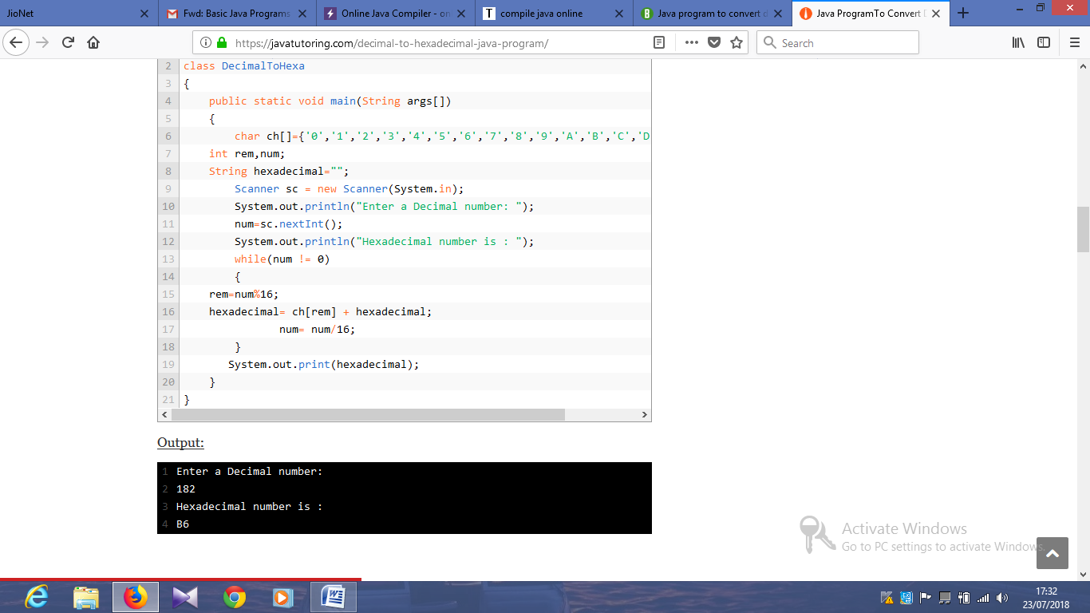

import java.util.Scanner;

public class Exercise22 {

public static void main(String[] args)

{

Scanner sc = new Scanner(System.in);

long binaryNumber, decimalNumber = 0, j = 1, remainder;

System.out.print("Input a binary number: ");

binaryNumber = sc.nextLong();

while (binaryNumber != 0)

{

remainder = binaryNumber % 10;

decimalNumber = decimalNumber + remainder * j;

j = j * 2;

binaryNumber = binaryNumber / 10;

}

System.out.println("Decimal Number: " + decimalNumber);

}

}

Output:

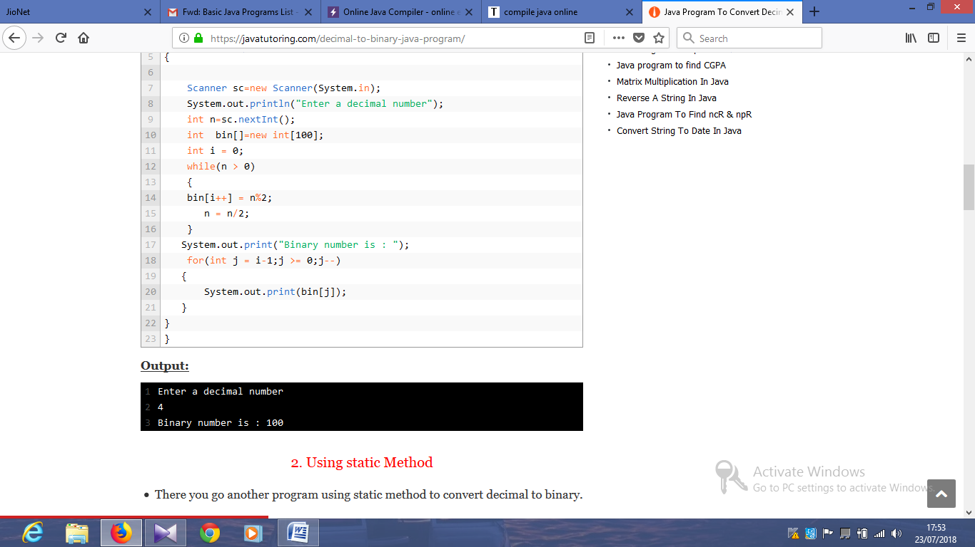

import java.util.Scanner;

public class Exercise23 {

public static void main(String[] args)

{

int[] hex = new int[1000];

int i = 1, j = 0, rem, dec = 0, bin;

Scanner in = new Scanner(System.in);

System.out.print("Input a Binary Number: ");

bin = in.nextInt();

while (bin > 0) {

rem = bin % 2;

dec = dec + rem * i;

i = i * 2;

bin = bin / 10;

}

i = 0;

while (dec != 0) {

hex[i] = dec % 16;

dec = dec / 16;

i++;

}

System.out.print("HexaDecimal value: ");

for (j = i - 1; j >= 0; j--)

{

if (hex[j] > 9)

{

System.out.print((char)(hex[j] + 55)+"\n");

} else

{

System.out.print(hex[j]+"\n");

}

}

}

}

import java.util.Scanner;

public class Exercise23 {

public static void main(String[] args)

{

int[] hex = new int[1000];

int i = 1, j = 0, rem, dec = 0, bin;

Scanner in = new Scanner(System.in);

System.out.print("Input a Binary Number: ");

bin = in.nextInt();

while (bin > 0) {

rem = bin % 2;

dec = dec + rem * i;

i = i * 2;

bin = bin / 10;

}

i = 0;

while (dec != 0) {

hex[i] = dec % 16;

dec = dec / 16;

i++;

}

System.out.print("HexaDecimal value: ");

for (j = i - 1; j >= 0; j--)

{

if (hex[j] > 9)

{

System.out.print((char)(hex[j] + 55)+"\n");

} else

{

System.out.print(hex[j]+"\n");

}

}

}

}

Output:

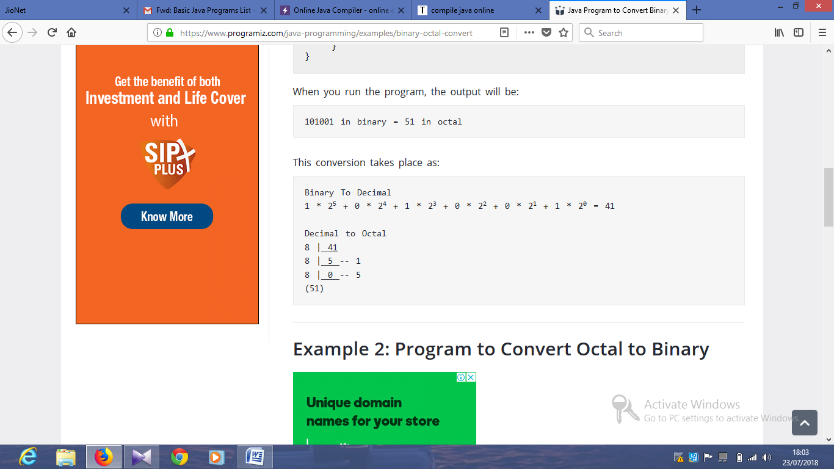

import java.util.Scanner;

class DECToOCT

{

     static int i=1;

    public static void main(String args[])

    {

        int dec, rem, q,j=1;

        Scanner sc = new Scanner(System.in);

        System.out.println("Enter a Dec number: ");

        dec=sc.nextInt();

        System.out.println("Oct number is : ");

        int[] oct=octal(dec);

        for(int c=i-1;c>0;c--)

        {

System.out.print(oct[c]);

        }

    }

static int[] octal(int q)

{

        int a[] = new int[50];

        while(q != 0)

        {

            a[i++] = q%8;

            q= q/8;

        }

        return a;

}

}

Output:

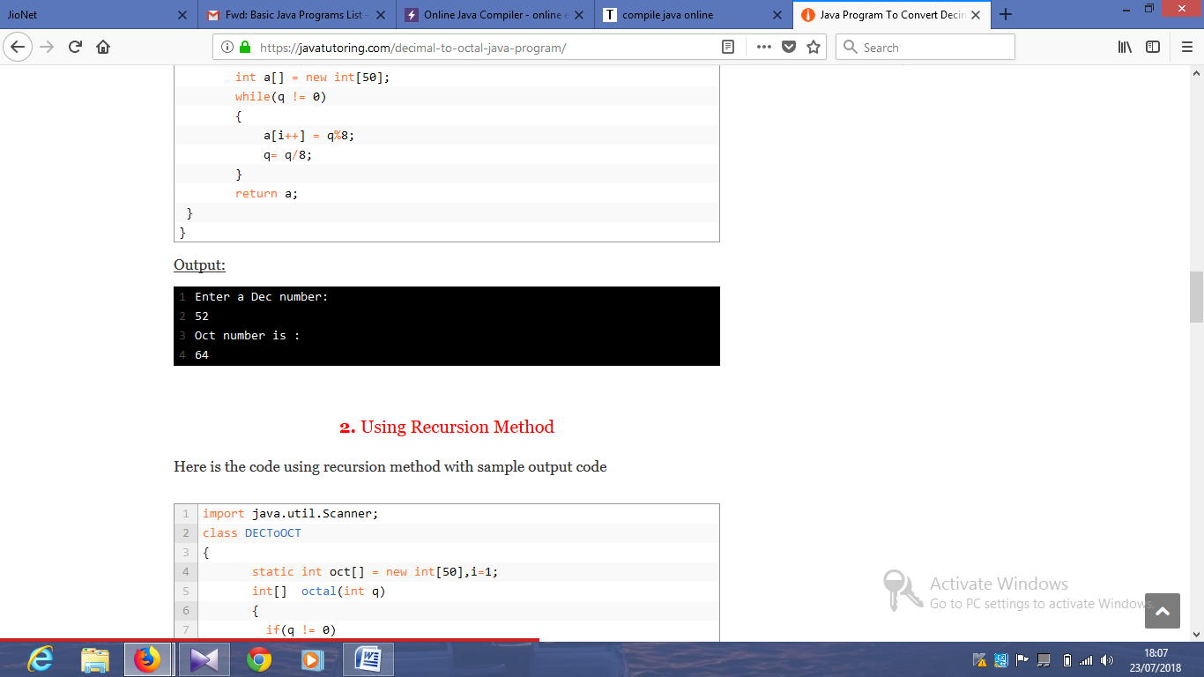

import java.util.Scanner;

public class JavaProgram

{

public static void main(String args[])

{

int octnum, rem, quot, i=1, j;

int binnum[] = new int[100];

Scanner scan = new Scanner(System.in);

System.out.print("Enter Octal Number : ");

octnum = scan.nextInt();

quot = octnum;

while(quot != 0)

{

binnum[i++] = quot%2;

quot = quot/2;

}

System.out.print("Equivalent Binary Value of " +octnum+ " is :\n");

for(j=i-1; j>0; j--)

{

System.out.print(binnum[j]);

}

}

}

Output:

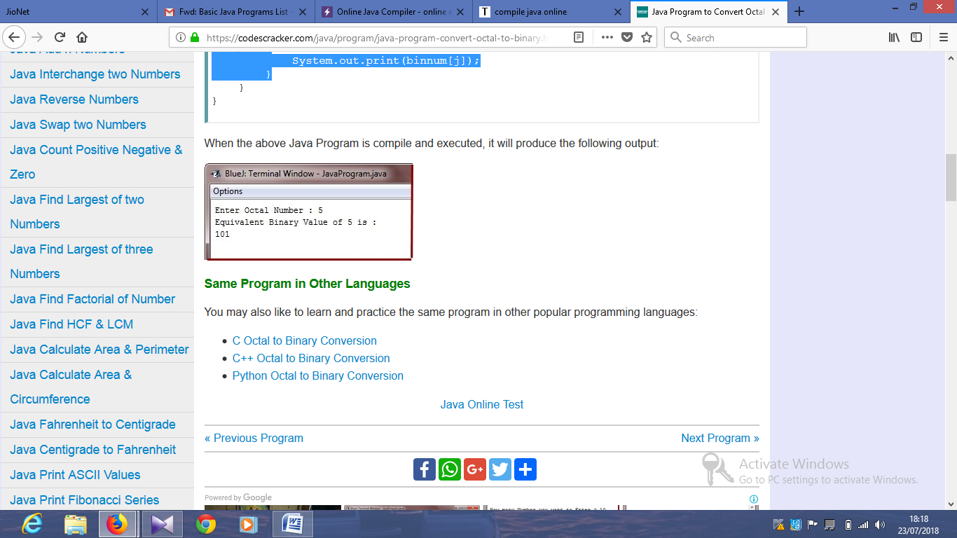

import java.util.Scanner;

class DecimalToHexa

{

    public static void main(String args[])

    {

     char ch[]={'0','1','2','3','4','5','6','7','8','9','A','B','C','D','E','F'};

int rem,num;

String hexadecimal="";

        Scanner sc = new Scanner(System.in);

        System.out.println("Enter a Decimal number: ");

        num=sc.nextInt();

        System.out.println("Hexadecimal number is : ");

        while(num != 0)

        {

rem=num%16;

hexadecimal= ch[rem] + hexadecimal;

               num= num/16;

        }

       System.out.print(hexadecimal);

    }

}

Output:

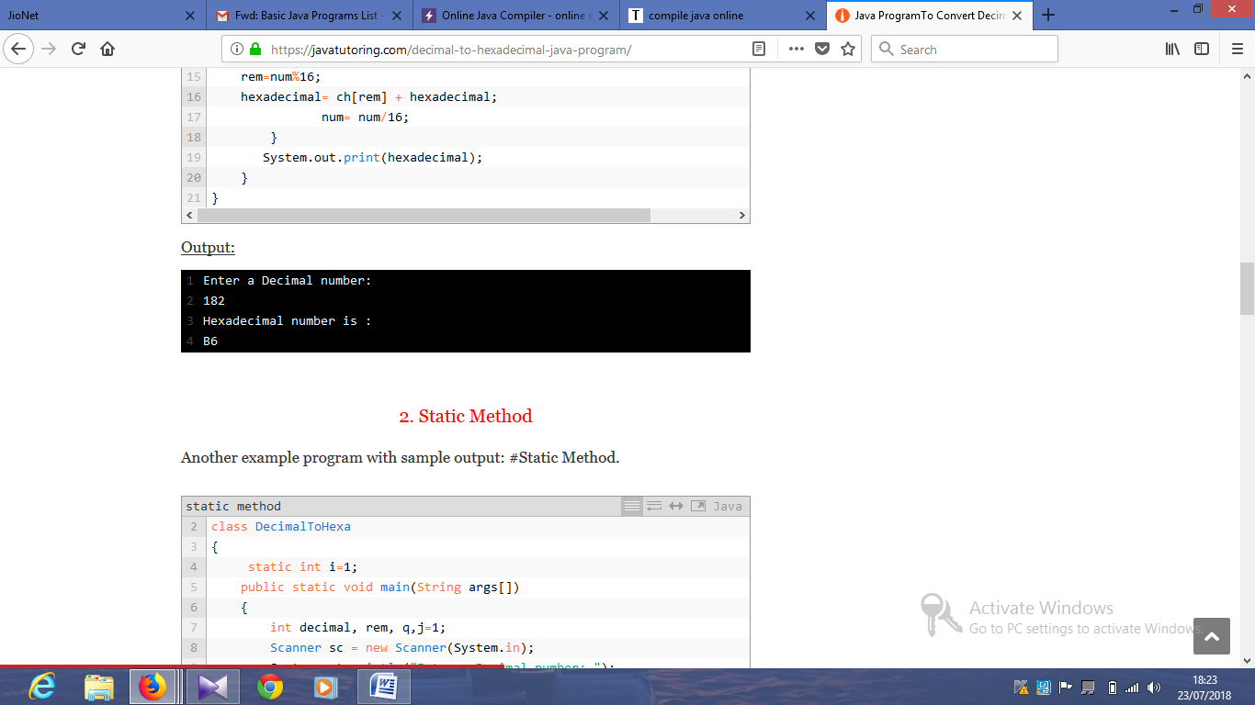

import java.util.Scanner;

public class Exercise29

{

public static int hex_to_decimal(String s)

{

String digits = "0123456789ABCDEF";

s = s.toUpperCase();

int val = 0;

for (int i = 0; i < s.length(); i++)

{

char c = s.charAt(i);

int d = digits.indexOf(c);

val = 16*val + d;

}

return val;

}

public static void main(String args[])

{

String hexdec_num;

int dec_num, i=1, j;

int bin_num[] = new int[100];

Scanner scan = new Scanner(System.in);

System.out.print("Enter Hexadecimal Number : ");

hexdec_num = scan.nextLine();

/* convert hexadecimal to decimal */

dec_num = hex_to_decimal(hexdec_num);

/* convert decimal to binary */

while(dec_num != 0)

{

bin_num[i++] = dec_num%2;

dec_num = dec_num/2;

}

System.out.print("Equivalent Binary Number is: ");

for(j=i-1; j>0; j--)

{

System.out.print(bin_num[j]);

}

System.out.print("\n");

}

}

import java.util.Scanner;

public class Exercise30 {

public static int hex_to_decimal(String s)

{

String digits = "0123456789ABCDEF";

s = s.toUpperCase();

int val = 0;

for (int i = 0; i < s.length(); i++)

{

char c = s.charAt(i);

int d = digits.indexOf(c);

val = 16*val + d;

}

return val;

}

public static void main(String args[])

{

String hexdec_num;

int dec_num, i=1, j;

int octal_num[] = new int[100];

Scanner in = new Scanner(System.in);

System.out.print("Input a hexadecimal number: ");

hexdec_num = in.nextLine();

// Convert hexadecimal to decimal

dec_num = hex_to_decimal(hexdec_num);

//Convert decimal to octal

while(dec_num != 0)

{

octal_num[i++] = dec_num%8;

dec_num = dec_num/8;

}

System.out.print("Equivalent of octal number is: ");

for(j=i-1; j>0; j--)

{

System.out.print(octal_num[j]);

}

System.out.print("\n");

}

}